EENG 385 - Electronic Devices and Circuits

Audio Board: Amplifier Measurements

Lab Handout

# Objective

The objective of this lab is to configure, use, and analyze the audio amplifier on the Audio board.

# Audio Amplifier Calibration

The heart of the Audio Amplifier is shown in the schematic shown in Figure 1. Today you will calibrate the bias voltage and Vbe voltage and then use your audio amplifier. To do this, you will need to refer to your previous week’s lab calculations. So before you start, access this document and keep it handy.

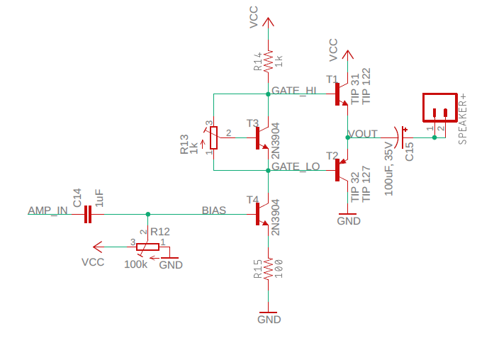

Figure : The core of the audio amplifier consists of a voltage gain stage followed by a current gain stage.

## 20 Turn Potentiometer

Last week you soldered in a pair of 20-turn potentiometers, a 1kΩ and 100kΩ like that shown in the left side of Figure 2. Look closely at the notation imprinted on the surface of the potentiometer in Figure 2 and you will see the letters “CW” printed next to the number 3. This means that as you turn the brass adjustment screw in a ClockWise (CW) direction the center tap (terminal 2) moves closer to the left pin (terminal 3). This is accomplished using a worm drive mechanism; the brass adjustment screw engages a gear attached to the center tap. The geared center tap moves around the carbon track connecting terminals 1 and 3. The worm drive acts like a gear reduction; this means that you need to rotate the brass adjustment screw 20 times to move the center tap from terminal 1 to terminal 3 (or vice versa). Note that the rotating the brass adjustment screw CounterClockWise (CCW) moves the center tap towards the right pin (terminal 1).

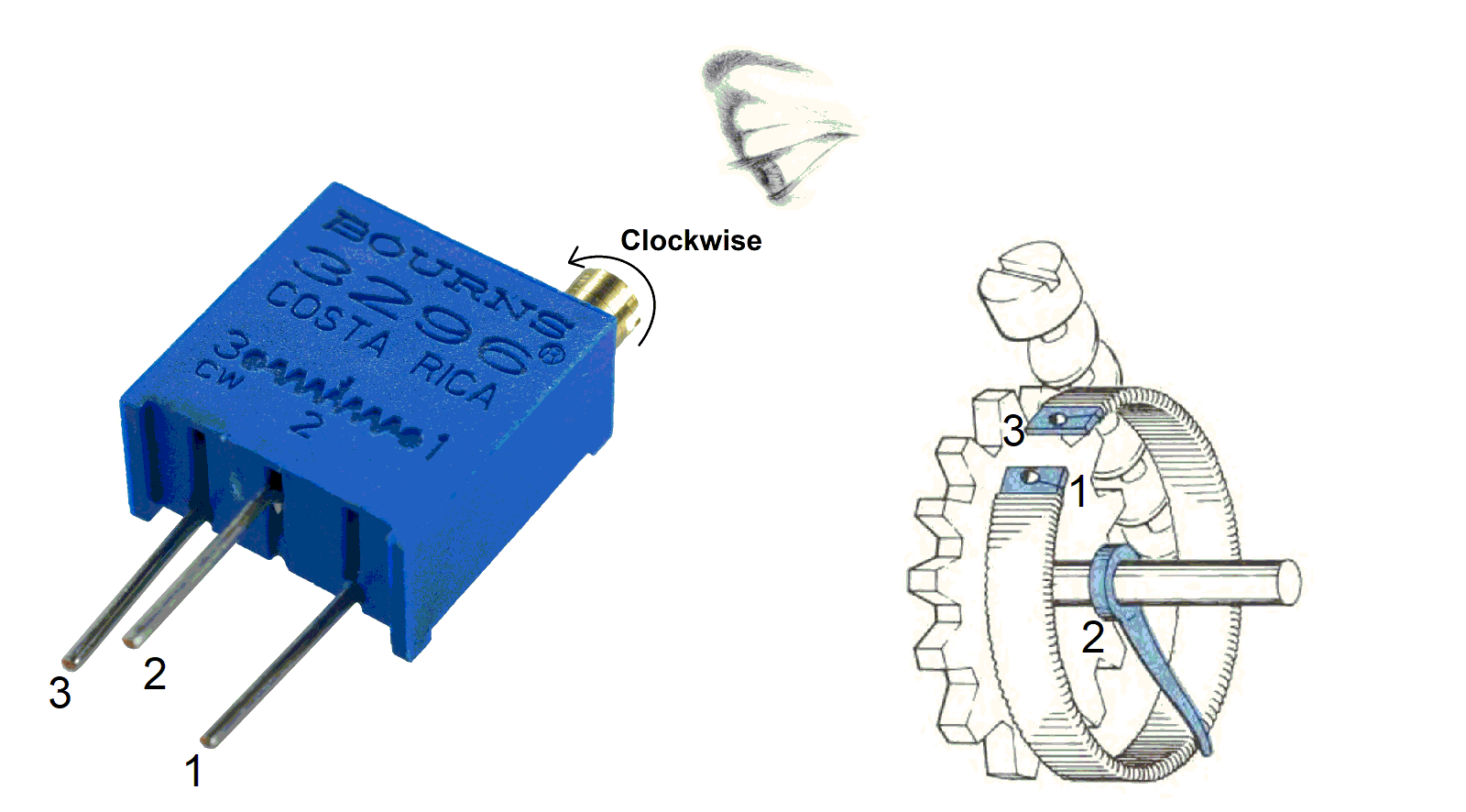

Figure : The internal structure of a 20-turn potentiometer.

## Audio Signal and the 3.5mm audio cable

This should be no surprise to you, but when you put on a pair of headphones to listen to music, your left and right ears hear slightly different audio producing stereo sound. The Audio board accepts stereo inputs from the 3-pole TRS cable shown in Figure 3. TRS stands for Tip, Ring, Sleeve; references to 3 metallic sections of the connector. You will connect an audio source to one end of the 3-pole TRS cable and the other end into the mating audio jack on the Audio board, at right in Figure 3. The left/right audio channel from the TRS cable will be available on the pair of headers labeled LEFT/RIGHT on the Audio board. Notice that the two LEFT headers are connected together with a wire (red line in Figure 3), so they carry identical signals. Same with the RIGHT headers.

You will apply a signal to the AMPIN header in Figure 3 to send an audio signal to the amplifier. The header pins in Figure 3 are placed 0.1” apart so you can use a 2-pin jumper to connect the LEFT or RIGHT audio channel to AMPIN. Unless you are dealing with a mono audio source (an audio source with a single channel), it does not matter if you send the LEFT or RIGHT audio channel to the AMPIN pin.

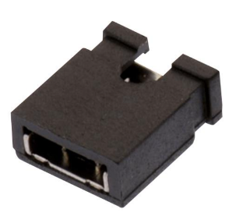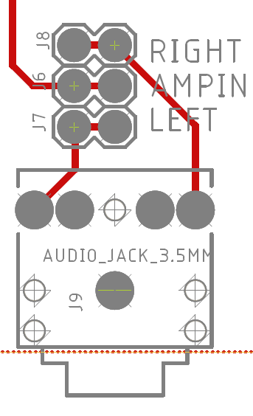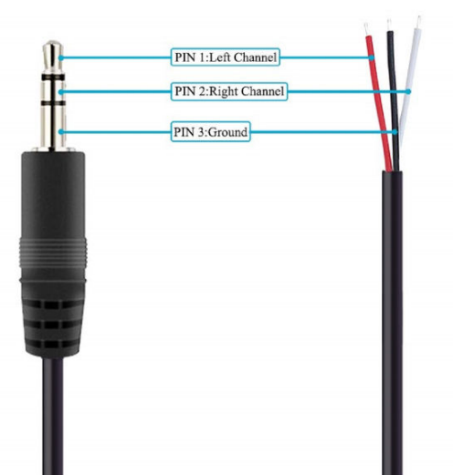

Figure : left, a 3-pole TRS cable audio cable. Center, the Audio board stereo input connector and associated header pins. Right, a 2 pin jumper used to connect the LEFT or RIGHT audio channel to AMPIN.

# Configure the Audio Board

Before you start work on today’s lab you need to perform an initial setup of your audio board. After soldering your components from last week your board will look something like that shown in Figure 4 with the exception of the components in the lower left corner, which you should NOT have installed.

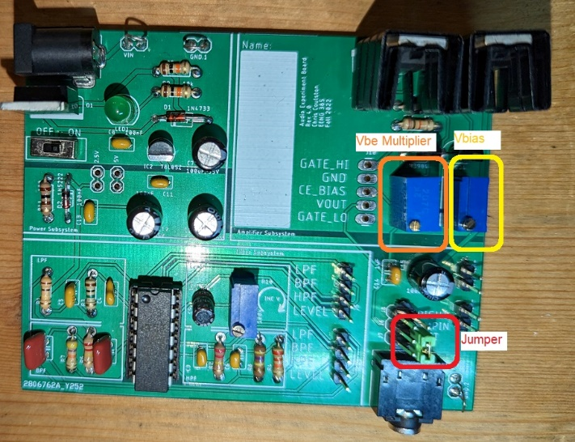

Figure : These are three items that need immediate attention before you start the lab. You should NOT have any components soldered into the lower left area of the board labeled LPF, HPF, BPF, LEVEL.

Note, if you soldered in your potentiometers upside-down, your brass screws will be towards the top of the board. Do not resolder your board, just reverse the CW, CCW directions in the instructions below.

* Vbe Multiplier POT (left one)
  + Turn the brass adjustment screw clock-wise (CW) at least 20 turns. Until it clicks
* Vbias POT (right one)
  + Turn the brass adjustment screw counter-clock-wise (CCW) for at least 20 turns. Until it clicks.
  + Then turn the brass adjustment screw clock-wise (CW) for exactly 4 turns.
* Install a jumper on the lower two header pins on the right side.
* Configure Lab power supply channel 1
  + Vmax= 16V
  + Imax = 0.2A
  + Connect power supply to your board, turn ON/OFF switch OFF.
* Login to the lab computers
  + Launch a web browser
  + Load youtube.com
  + Run the video “1000 Hz Sine Wave The Ultimate 10 Hour Test Tone | 1kHz”
  + Experiment so you know how to adjust the volume, then pause the video.
* Grab a 3.5mm audio cable
* Grab a 2” speaker

# Calibrate With an Audio Signal

Let’s apply an audio to the amplifier and fine tune the bias voltage and Vbe multiplier in preparation to apply an audio signal. To do this, first configure your oscilloscope as follows:

|  |  |
| --- | --- |
| Horizontal (scale) | 500us |
| Ch1 probe | GATE_LO header |
| Ch1 (scale) | 2V/div |
| Ch1 (coupling) | DC |
| Ch2 probe | GATE_HIGH header |
| Ch2 (scale) | 2V/div |
| Ch2 (coupling) | DC |
| Trigger source | 1 |
| Trigger slope | ↑ |
| Trigger level | 8V |

Make sure to align the channel 1 and 2 ground references to the bottom edge of the oscilloscope display.

## Tune Bias Voltage

Adjusting the bias voltage changes the DC operating point of the output transistors T1 and T2 in Figure 1 which in turn determines VOUT. You can think of the operating point as the average value of the VOUT signal, its middle value. To get this right, perform the following.

1. Power on your audio board so that the green LED lights up.
2. Start the youtube audio producing an unplesant high pitch tone from your lab computer.
3. Next connect the PC to the audio board using the 3.5mm audio jack and the green 3.5mm jack on the back of the PC. The sound will stop from the PC when you have this correct.

Now adjust the Vbias potentiometer so that VOUT is centered at 8V. shows how this will look on the oscilloscope.

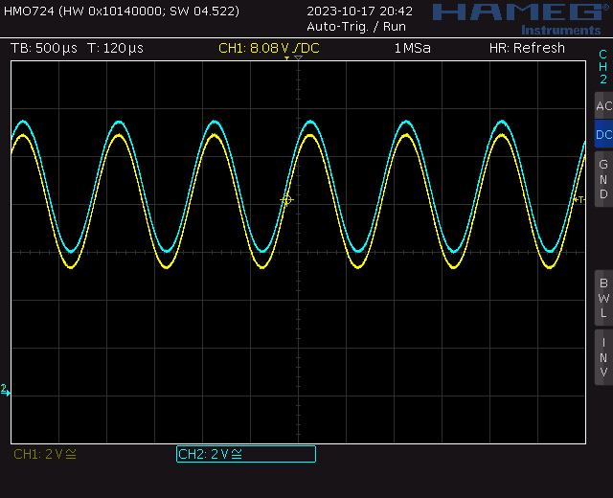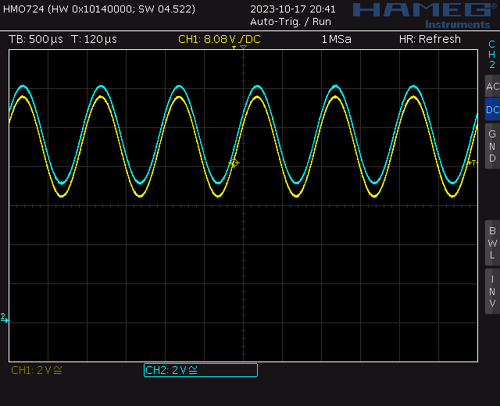

Figure : (left) The default waveforms from the GATE_HI and GATE_LO pins when you follow the steps in the CONFIGURE AUDIO BOARD section. (right) After some adjustment you should be able to get channel 1 centered at 8V.

## Tune Vbe Multiplier

It’s important to get the Vbe multiplier tuned because this is the one items that will cause the output transistors to overhead. In other words, if your output transistors are overheating it’s almost certainly a result of your Vbe multiplier being mis-adusted. It is MUCH easier to set the BIAS voltage with a speaker attached.

Adjusting the Vbe multiplier changes when the T1 and T2, in Figure 1, conduct. When you set the voltage across the Vbe multiplier too high, both T1 and T2 will conduct at the same time. This will cause a short circuit between the Vcc and GND rails causing very high power disipation in T1 and T2. When you set the voltage across the Vbe multiplier is set too low, there will be times when neither T1 and T2. This will cause a flat spot in VOUT and a distorted audio output.

Both of these unwanted situations are a mistiming in turning one of the output transistors on turing the other transistor on. This is called cross-over distortion because the output signal is crossing over from one of the transistors to the other. You need to adjust the Vbe multiplier so that the sinusoidal output has no cross-over distortion, so that output waveform has no distortions in the middle. Figure 6 shows how to adjust the VBE potentiometer to eliminate cross over distortion.

Your oscilloiscope should display the image at left in Figure 6. Now start to turn the Vbe POT in the CCW direction. After a bunch of turns (10 or more), you should start to see the waveforms separate. When you get them to about 2V (center in Figure 6), start monitoring the power supply as you continue to turn the Vbe POT in the CCW direction. At some point the current drawn from the power supply will rapidly jump – this marks the point where both T1 and T2 are turned on at the same time and you are shorting the power supply through T1 and T2. This is not a good thing, so back off the Vbe POT by turning it CW until the current drops back to what it was before (around 10mA to 20mA). If you are not paying attention to the power supply, you will notice that the channel 1 and channel 2 waveforms start to loose voltage when the Vbe POT is turned too far CCW as shown at right in Figure 6.

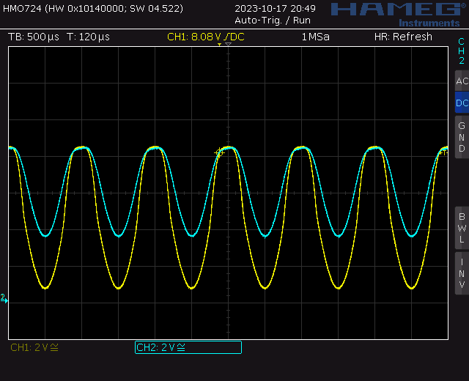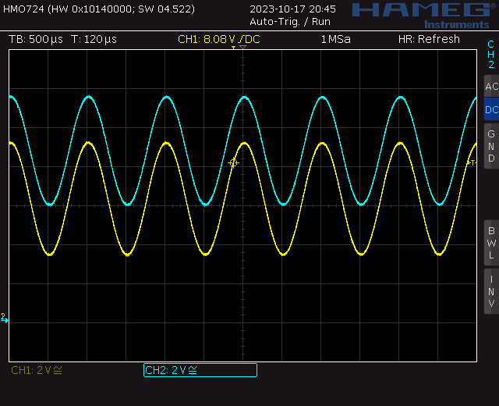



*Figure 6: (left) The default waveforms from the GATE_HI and GATE_LO pins after centering channel 1 at 8V in the previous step. (middle) After some CCW adjustment on the Vbe POT,* *I separated the two waveforms by about 2.4V – perfect. (right) when the Vbe POT is turned too far CCW, you are shorting the power supply across the T1 and T2 Darlington pairs – bad.*

## Re-Tune Bias Voltage

In the previous step you may have moved the waveforms away from the 8V center value. Adjust the Vbias POT to recenter the pair of waveforms so that their average value is 8V. You are now ready to do some further testing with your audio amplifier.

# Amplifier Measurements

Compute the voltage gain from the signal source to the Vout by forming the ratio of Vout amplitude over Vin amplitude. Note that this is the same quantity as the Vef/Vs ratio you computed in last week’s lab. In order to do this reconfigure your oscilloscope as follows:

|  |  |
| --- | --- |
| Horizontal (scale) | 1ms |
| Ch1 probe | AMP_IN jumper |
| Ch1 (scale) | 0.2V/div |
| Ch1 (coupling) | DC |
| Ch2 probe | Vout header |
| Ch2 (scale) | 2V/div |
| Ch2 (coupling) | DC |
| Trigger source | 1 |
| Trigger slope | ↑ |
| Trigger level | 8V |

Make sure to align the channel 1 and 2 ground references to the bottom edge of the oscilloscope display.

Some notes about this measurement:

* Center the input on the lower half of the oscilloscope display and center the output in the upper half.
* Use the Acquire function to smooth out the waveforms.
* Consider using the measurement tool to measure the amplitude.
* A 180° phase change from input to output represents a negative gain.

Screen shot the oscilloscope and use the values on the oscilloscope to compute the gain. The data shown in Figure 7 has a gain of 1140mV/129mV = -8.8. This is close to the gain of -10 that you should have gotten in last week’s lab for the unloaded Vef/Vs ratio.

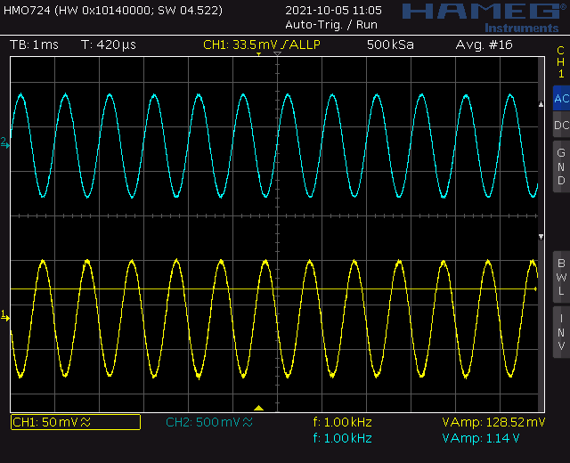

Figure : Oscilloscope capture of an unloaded common emitter input and output - no speaker attached.

Now connect a speaker to and screen shot the oscilloscope. Use the values on the oscilloscope to compute the gain of the loaded amplifier. The data shown in Figure 8 has a gain of 516mV/129mV = -4. This is close to the gain of -4.4 that you should have gotten in last week’s lab for the unloaded Vef/Vs ratio.

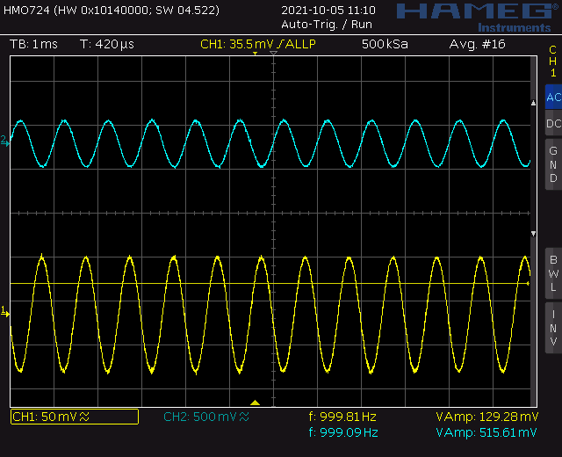

Figure : Oscilloscope capture of a loaded common emitter input and output – 8Ω speaker attached.

As a final test let’s use the oscilloscope’s built in frequency response subsystem to generate a Bode plot of the unloaded amplifier. To perform this test:

* Disconnect the 3.5mm audio cable and stop the youtube video.
* Connect a T-connector to function generator output of the oscilloscope. The function generator output of the oscilloscope is just above the power button.
* Connect BNC to BNC cable from T-connector to Channel 1 input
* Connect function generator cable from T-connector to AMPIN pin with the red alligator clip and GND loop to the black alligator clip. You will need a small jumper wire to connect the red alligator clip to the AMPin header pin. The left AMPin pin is electrically connected to the right AMPin pin so it doesn’t matter which you connect to.
* Connect Channel 2 to the VOUT header on amplifier board.
* Press the Analysis button (just above the Ch2 vertical scale knob)
* Press the Features softkey and select FRA
* Make sure the setup tab (gear icon) is selected
  + Frequency Mode Sweep
  + Frequency (Start, Stop) 10Hz 1MHz
  + Points per decade 10
  + Source (Input, Output) 1 2
  + WaveGen 200mVpp 50Ω
* Press Run Analysis. The screen displays the input and output waveform as data is bring collected.
* The graph tab should auto select and display the Bode Plot for the audio amplifier.

# Apply an Audio Source

Reconnect your 3.5mm audio cable between an audio source and the audio board. Put some tunes on and listen to the output. Enjoy, you’ve earned it.

# Turn In

Make a record of your response to numbered items below and turn them in a single copy as your team’s solution on Canvas using the instructions posted there. Include the names of both team members at the top of your solutions. Use complete English sentences to introduce what each of the following listed items (below) is and how it was derived.

**Amplifier Measurements**

Screen shot of input and output with no-load

Calculation of no-load gain

Screen shot of input and output with 8Ω speaker

Calculation of 8Ω gain.

Bode plot for amplifier

**Apply an Audio Source**

Demo working amplifier by playing a song